Week 8 Assignment on Vehicles

Precious Brown
IS362: Data Acquisition and Management

Introduction
For this assignment, I worked with the Auto MPG dataset from the UCI Machine Learning Repository (repo). I used pandas to load and review the data, handle missing horsepower values, and to update the origin labels. I also used matplotlib and seaborn to explore cylinder counts and the relationships between things such as weight, horsepower, and fuel efficiency.
I started by loading the auto-mpg.data file from the UCI link. Initially the file did not have column headings, so I used the attribute information in auto-mpg.names to give names to each of the nine columns.
The dataset contained 398 rows and 9 columns. I used head() to look at the first few records, info() to check the column types, and describe() to look over the numerical summaries. The horsepower column initially appeared as an object instead of a numeric column due to the missing measurements which were marked with question marks.

Data Cleanup
I replaced the missing horsepower values with NaN instead of zero because a missing measurement does not mean that the car has zero horsepower, it just means that in this dataset, the information is unavailable. If I used zero, it would add inaccurate data that would directly affect the results.
There were six missing horsepower measurements. I kept these rows in the dataset, but chose not to include them in the horsepower scatterplot. I also converted horsepower to numeric data after replacing the question marks.
In efforts to follow the assignment instructions I changed the origin values from 1, 2, and 3 to USA, Asia, and Europe.

The Cylinder Distribution
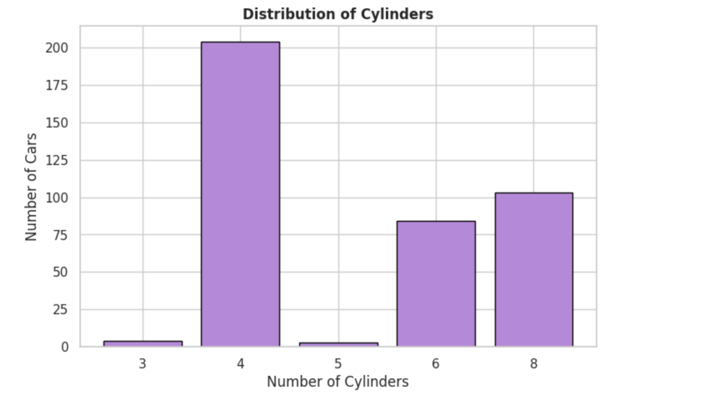
During this assignment, I noticed that the cars with 4, 6, and 8 cylinders were more common in the dataset than cars that had 3 or 5 cylinders. Cars with four cylinders had the highest count at 204, followed by 103 eight cylinder cars and 84 six cylinder cars. There were only 4 three cylinder cars and 3 five cylinder cars.
The bar chart made it much easier to compare the number of cars in each group, by providing a visual aid.

Vehicle Weight and Horsepower
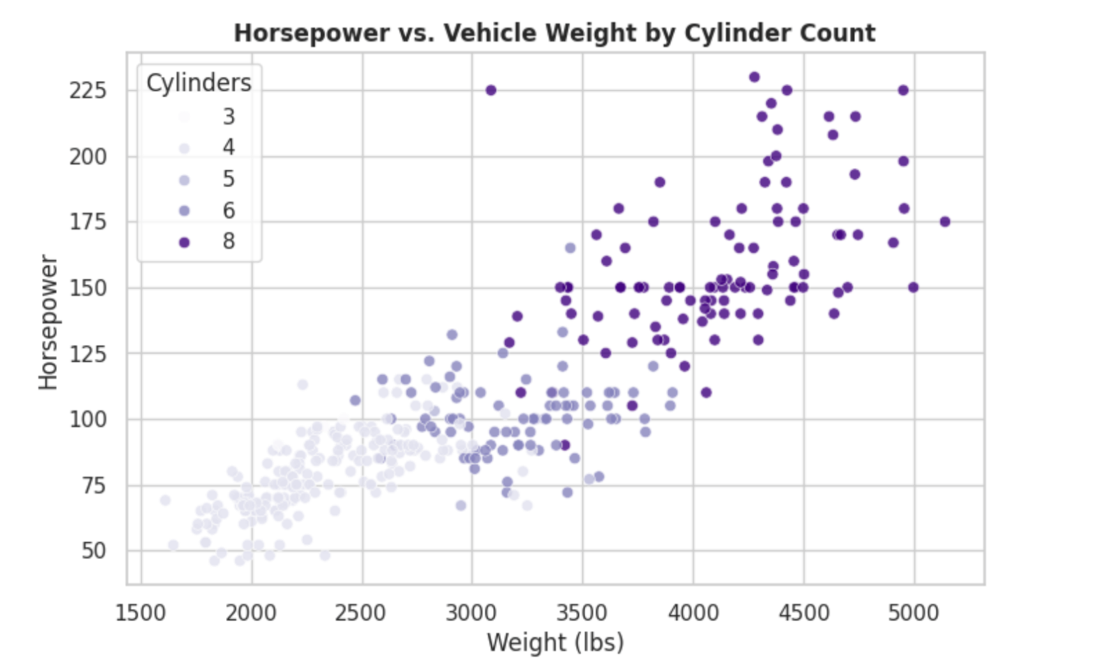
This part of the project was in my opinion the best visual aid. I noticed that the heavier cars in the dataset had the highest horsepower. I chose to color the points based on the number of cylinders, to make it a bit easier to see where each group of cars landed in relation to weight and horsepower.
The eight cylinder vehicles were clustered in the upper right of the horsepower and weight chart, showing that both weight and horsepower were higher. This clearly shows an association among the variables. I kept note that this chart shows correlation rather than causation. The chart included 392 cars due to the six records in which horsepower measurements were absent.

My question: Is There a Relationship Between Vehicle Weight and Fuel Efficiency?
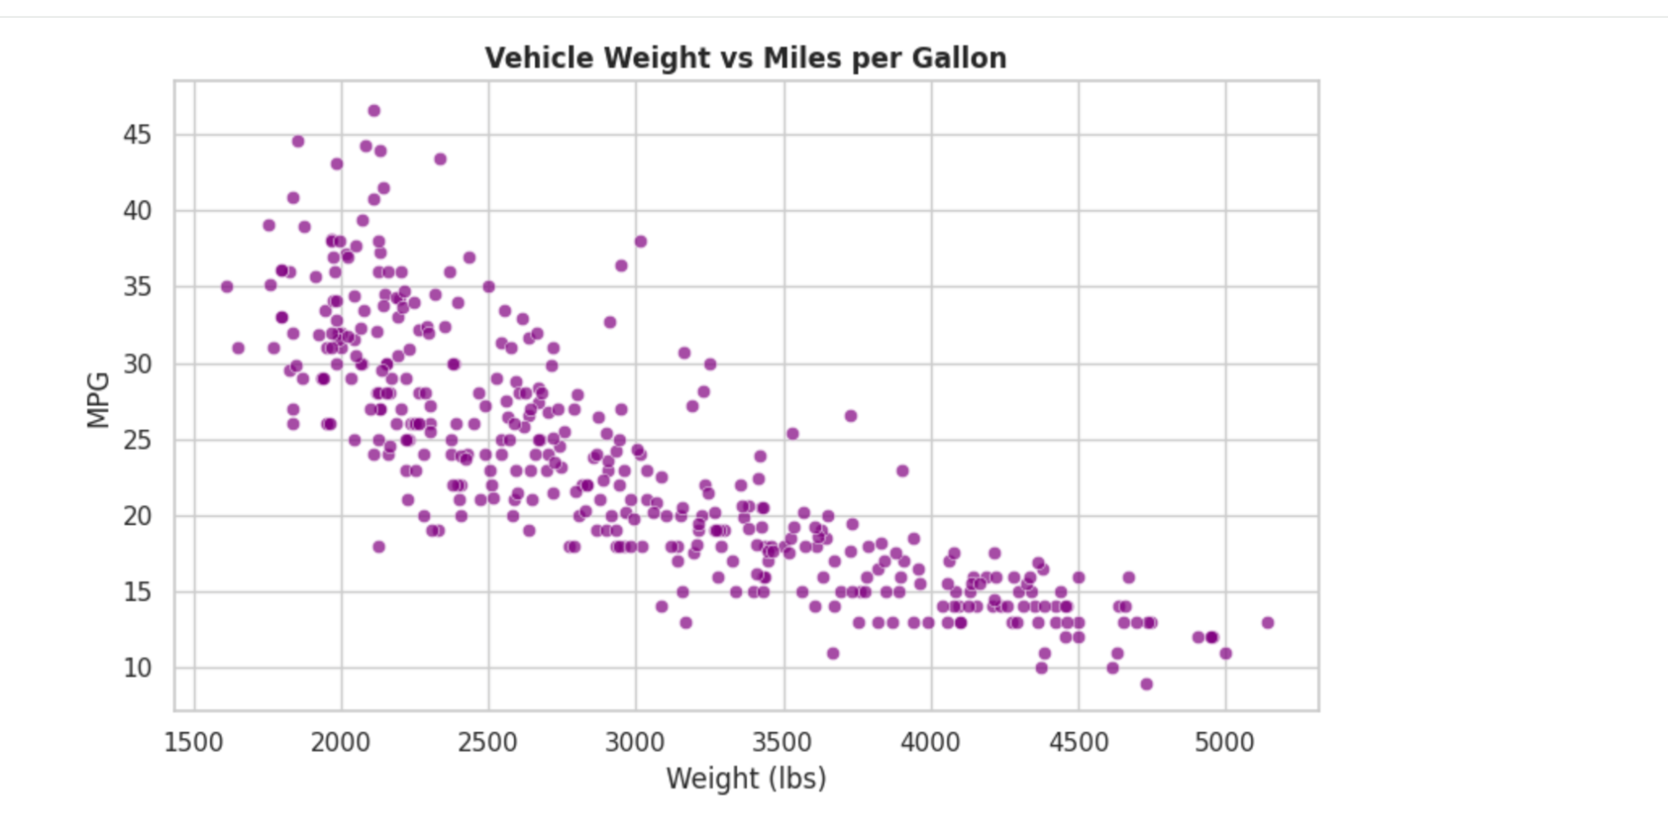
While looking at the scatterplot, I noticed the heavier cars in this dataset had higher horsepower. Lighter cars trended with higher MPG, although there were some variations. Some cars reached 30 MPG and only a few went above 40 MPG.
The heavier cars were grouped mostly toward the lower right of the graph, where MPG was lower and the weight of the vehicle was heavier.
This shows a relationship between weight and MPG in the dataset, but it does not prove that weight alone caused the difference.

Issues
While editing my notebook in Colab, I accidentally placed an explanation in a code cell instead of a Markdown cell. This caused a syntax error because Python tried running my paragraph as a code. I moved the explanation into a Markdown cell, put the plotting code back in a code cell, and ran it again. After that, I checked the cell types and ran all the cells in my notebook again.

Conclusion
Four cylinder cars were the most common in the dataset, Heavier cars tended to have higher horsepower and lower MPG. The charts helped me see these patterns, and converting the horsepower column over to numeric values allowed for me to use it in my analysis.

References
Quinlan, R. (1993). Auto MPG [Dataset]. UCI Machine Learning Repository.
https://doi.org/10.24432/C5859H
Dataset attribute descriptions:
https://archive.ics.uci.edu/ml/machine-learning-databases/auto-mpg/auto-mpg.names

